 **Year 7 – Humanities and Social Sciences**

**Assessment 9 - PART A: 15%**

**Inquiry Task**

**A**

**Name: __________________________________ Class: ______________**

|  |  |  |  |
| --- | --- | --- | --- |
| **Your Target** | **Mark** | **Percentage** | **Weighting** |
| **Inquiry Process**  **/55** | **Inquiry Process**  **/ 55** |  | **15%** |

**Date Due: Week 5 Term 2.**

**_____________________**

**Section One (PART A): Inquiry Process**

Investigate key features of Australia’s Legal System.

* Use the inquiry booklet to record your information, including the brainstorm, KWL Chart
* You will have 2 lessons to conduct your inquiry; the rest of the project must be completed in your own time.
* Lastly, remember to include a bibliography. A range of references must be used.
* Complete the PMI Chart. This is to evaluate the task.
* You will need to research information on the following 5 key topics

**The following key topics you must cover using bullet points:**

1. **Key Topic 1: The Rule of Law**
2. **Key Topic 1: The Presumption of Innocence**
3. **Key Topic 3: The Burden of Proof**
4. **Key Topic 4: The Right to a Fair Trial**
5. **Key Topic 5: The Right to Legal Representation**

**PART A**: Inquiry Booklet

**Brainstorm**

Use the box provided below to brainstorm examples of any key features you know about Australia’s legal system

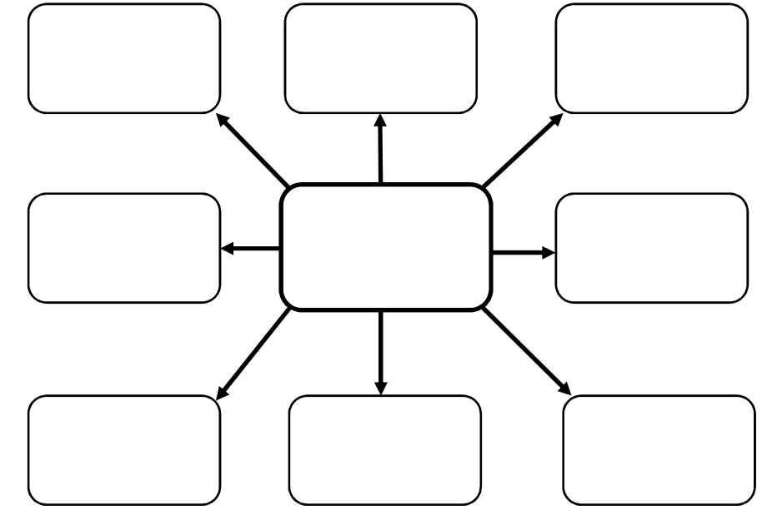

**Complete the KWL chart below**

|  |  |  |
| --- | --- | --- |
| K | W | L |
| What do you already **know** about the topic? | What do you **want** to know about the topic? | What have you **learned** about the topic? |
|  |  |  |

Define the term ***outline***: _________________________________________________________

_____________________________________________________________________________

_____________________________________________________________________________

**Key Topic 1: Rule of Law**

|  |
| --- |
| Inquiry topic/question: **Outline** what the Rule of Law is |

**Key points from information sources and reference details (5 marks)**

|  |
| --- |
| * Separation of powers – this means that each of the three branches og government acts separately and acts as a check on the others. This keeps the other branches from gaining too much power or acting oppressively. * Fairness – laws apply equally to everyone – no one is above the law, and laws apply whether or not someone is an Australian * procedural fairness – procedures or processes of applying the law should be fair and predictable. People should be treated consistently. * judicial precedent – legal decisions made previously are taken into account in later cases. Cases with similar facts should have similar verdicts. Judges must identify how cases that seem similar are actually different if they want to treat them differently. * judicial independence – judges make unbiased decisions about eh case without the government telling them how to decide an outcome |

**Key Topic 2: The Presumption of Innocence**

|  |
| --- |
| Inquiry topic/question: **Outline** what is the Presumption of Innocence |

**Key points from information sources and reference details (5 marks)**

|  |
| --- |
| * belief that a person accused of committing a crime is innocent until proven guilty. * the accused does not have to prove his or her innocence * the person making the accusation has to establish guilt – if the prosecutor cannot establish guilt, the accused is entitle to be set free * The prosecutor has to prove you are guilty; they have to prove you are guilty “beyond reasonable doubt”. * The rationale is that it is better that the guilty go free than that the innocent be convicted |

**Key Topic 3: The Burden of Proof**

|  |
| --- |
| Inquiry topic/question: **Outline** what is the Burden of Proof |

**Key points from information sources and reference details (5 marks)**

|  |
| --- |
| * One of the basic principles of adversarial legal systems. * Two important ideas: who has the responsibility of proving what is alleged and to what standard. * In Australia, the responsibility and standard of proof for civil and criminal cases are different. * Civil cases – responsibility of proof rests on the side making the complaint – called the plaintiff. The plaintiff has to prove to the judge magistrate or jury that the claim is true – balance of probabilities. This is the Civil law standard of proof. * Criminal cases – a higher standard of proof is needed. Magistrate or jury must be convinced beyond reasonable doubt – the accused would almost certainly have to be guilty. Beyond reasonable doubt – that the accused is guilty. |

**Key Topic 4: The Right to a Fair Trial**

|  |
| --- |
| Inquiry/question: **Outline** what is the Right to a Fair Trial |

**Key points from information sources and reference details (5 marks)**

|  |
| --- |
| * All people have basic legal rights. This is known as natural justice. * All people should be given a fair hearing and the chance to present the other side of the story. * Each person is entitled to hear the case against them – they have a right to question the other side and to raise arguments against any opponent. * Natural justice also means judges must be even handed and fair. They cannot favour one party over another. * Judge can decide if a jury should hear particular evidence. |

**Key Topic 5: The Right to Legal Representation**

|  |
| --- |
| Inquiry/question: **Outline** what is the Right to Legal Representation |

**Key points from information sources and reference details (5 marks)**

|  |
| --- |
| * Justice should be available to everyone, not just those who can afford expensive lawyer fees. * Sources of legal help exist for people who are unable to pay lawyers’ fees to ensure that get quality legal representation. * Legal help groups exist in the form of Legal Aid Commission which provides legal services for free. These bodies offer phone advice and representation in court. * It is also important to provide remote access to the legal system for people living in regional and rural areas (country areas). * An essential feature of our justice system is that everyone has a fair go and so that people can defend themselves. Especially if they may have been taken to Court by mistake. |

**Complete the PMI chart below TASK**

|  |  |  |
| --- | --- | --- |
| P – Plus | M - Minus | I - Interesting |
| **Positives (Pluses)**  **about the task** | **Negatives (Minuses)**  **about the task** | **Interesting parts**  **of the task** |
|  |  |  |

**TOPIC**

|  |  |  |
| --- | --- | --- |
| P – Plus | M - Minus | I - Interesting |
| **Positives (Pluses)**  **about the topic** | **Negatives (Minuses)**  **about the topic** | **Interesting parts**  **of the topic** |
|  |  |  |

**Assessment 8: Year 7 – Civics and Citizenship Research Inquiry Task – Checklist/Marking Key**

|  |  |  |
| --- | --- | --- |
| **Assessment Task** | |  |
| **Inquiry Booklet** | **Marks Available** | **Your Marks** |
| **Description** |  |  |
| **KLW Chart – Completed KWL Chart**  Includes 5-6 key points under each heading or has used detail for at least two columns, such as ‘Want to Know and Learnt’. Uses a brief explanation for each point. | 5-6 |  |
| Includes 3-4 key points under each heading or has used some detail for at least two columns, such as ‘Want to Know and Learnt’. Uses basic detail. | 3-4 |  |
| Includes 1-2 key point under each heading. No detail provided. | 1-2 |  |
| **Subtotal** | 6 |  |
| **Description** |  |  |
| **Brainstorm – Completed Brainstorm** |  |  |
| Includes 7-8 brainstorm points inside each bubble. | 7-8 |  |
| Includes 5-6 brainstorm points inside each bubble. | 5-6 |  |
| Includes 3-4 brainstorm points inside each bubble. | 3-4 |  |
| Includes 1-2 brainstorm points inside each bubble. | 1-2 |  |
| **Subtotal** | 8 |  |
| **Description** | |  |
| **Key Topic 1: Rule of Law** | |  |
| **Outlines** five key points of information relevant to the topic | 5 |  |
| **Outlines** four key points of information relevant to the topic | 4 |  |
| **Outlines** three key points of information relevant to the topic | 3 |  |
| **Outlines** two key points of information relevant to the topic | 2 |  |
| **Outlines** one key point of information relevant to the topic | 1 |  |
| **Subtotal** | 5 |  |
| **Key Topic 2: Burden of Proof** |  |  |
| **Outlines** five key points of information relevant to the topic | 5 |  |
| **Outlines** four key points of information relevant to the topic | 4 |  |
| **Outlines** three key points of information relevant to the topic | 3 |  |
| **Outlines** two key points of information relevant to the topic | 2 |  |
| **Outlines** one key point of information relevant to the topic | 1 |  |
| **Subtotal** | 5 |  |
| **Key Topic 3: The Presumption of Innocence** |  |  |
| **Outlines** five key points of information relevant to the topic | 5 |  |
| **Outlines** four key points of information relevant to the topic | 4 |  |
| **Outlines** three key points of information relevant to the topic | 3 |  |
| **Outlines** two key points of information relevant to the topic | 2 |  |
| **Outlines** one key point of information relevant to the topic | 1 |  |
| **Subtotal** | 5 |  |
| **Key Topic 4: The Right to a Fair Trial** |  |  |
| **Outlines** five key points of information relevant to the topic | 5 |  |
| **Outlines** four key points of information relevant to the topic | 4 |  |
| **Outlines** three key points of information relevant to the topic | 3 |  |
| **Outlines** two key points of information relevant to the topic | 2 |  |
| **Outlines** one key point of information relevant to the topic | 1 |  |
| **Subtotal** | 5 |  |
| **Key Topic 5: The Right to Legal Representation** |  |  |
| **Outlines** five key points of information relevant to the topic | 5 |  |
| **Outlines** four key points of information relevant to the topic | 4 |  |
| **Outlines** three key points of information relevant to the topic | 3 |  |
| **Outlines** two key points of information relevant to the topic | 2 |  |
| **Outlines** one key point of information relevant to the topic | 1 |  |
| **Subtotal** | 5 |  |
| **Description** | |  |
| **Organisation of information and/or data** | |  |
| Organises information and/or data into clear categories using appropriate subheadings | 5-6 |  |
| Organises information and/or data into some categories using subheadings | 3-4 |  |
| Organises information and/or data in a limited fashion | 1-2 |  |
| **Subtotal** | 6 |  |
| **Description** | |  |
| **Bibliography** | |  |
| Follows correct format according to referencing technique approved by the school | 3-4 |  |
| Lists sources used | 1-2 |  |
| **Subtotal** | 4 |  |
| **Description – Evaluating and Reflecting** |  |  |
| **PMI Chart – Completed PMI Chart (Task and Topic)**  Includes 5-6 key points in total for the task (2 under each heading).  Includes 3 points for the topic (1 under each heading)  Uses a brief explanation for each point. | 5-9 |  |
| Includes 3-4 key points under each heading. Uses basic detail. | 3-4 |  |
| Includes 1-2 key point under each heading. No detail provided. | 1-2 |  |
| **Subtotal** | 6 |  |